**JS Psych Questionnaires**

Written by Angie, Kim, Jen, and Yubing for the AND Lab

We’ve uploaded the questionnaires for the safety learning study on Github: “QuestionnairesFormal” and “QuestionnairesTest”. “QuestionnairesTest” is just a test version without the requirement of filling in all the questions.

Here is a repository created by Angie for all the questionnaires we’ve already coded:

<https://docs.google.com/spreadsheets/d/12vwGnMP2F58iHFLlN8zrkA3TtjmyJWQHzaTxmFuKP_0/edit?usp=sharing>

Please let us know if anything is unclear in this instruction or in the example, we will try to check what’s going on. Also, please feel free to modify or add comments to this file to make it clearer for future lab members!☺

Table of Contents

1. A Brief Introduction to the Files 3

2. Modifying an Individual File 4

Example: A Likert Scale Questionnaire 4

Other Types of Surveys/Functions 7

3. Combining Individual Files into .html 9

4. Uploading for Data Collection 10

5. How the Data would Look Like 11

6. Some Other Things 12

Make Answering Questions Required & in the Right Format 12

Conditional Questions 13

Showing Different Questionnaires to Different Participants 14

7. Trouble shooting 15

# A Brief Introduction to the Files

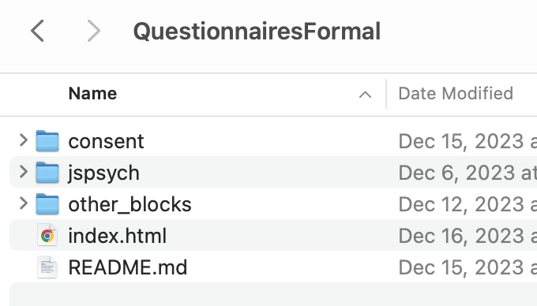

🡨 All the folders we have in “QuestionnairesFormal”

1. 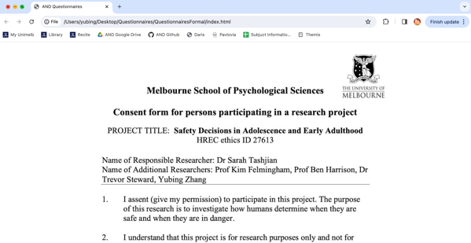The .html file is the summary file where everything is put together. You can open it with your browser for preview or with any coding software for modification (Visual Studio Code: <https://code.visualstudio.com/>).

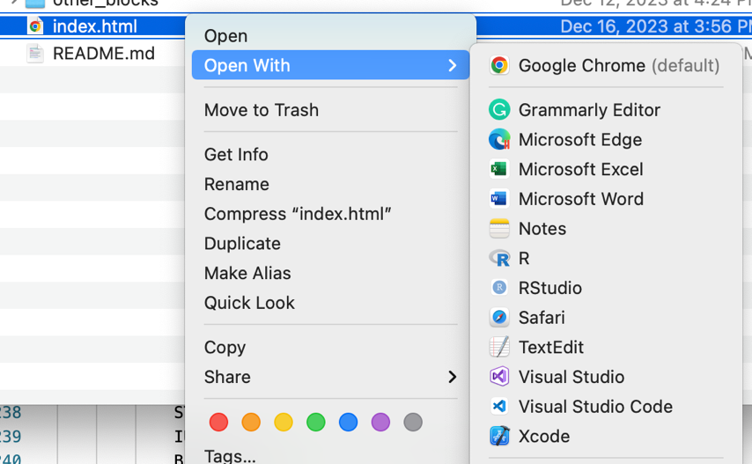

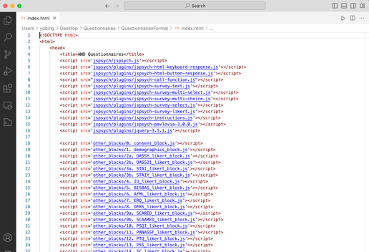

1. All the individual questionnaires are coded in separate files in the “other_blockes” folder.
2. You generally don’t need to modify the plugins or anything in the “jspsych” folder, just leave it as it is.

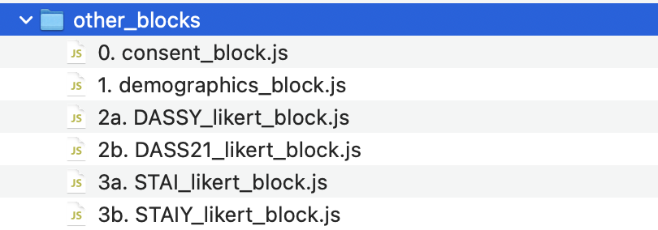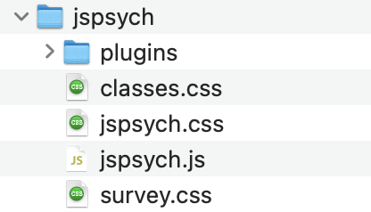

# Modifying an Individual File

## Example: A Likert Scale Questionnaire

Using “**2a. DASSY_likert_block.js**” as an example, the first few lines create an instruction on a separate web page:

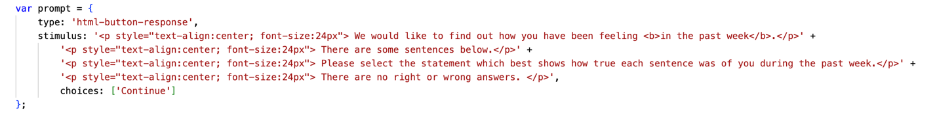

What’s showing on the web page:

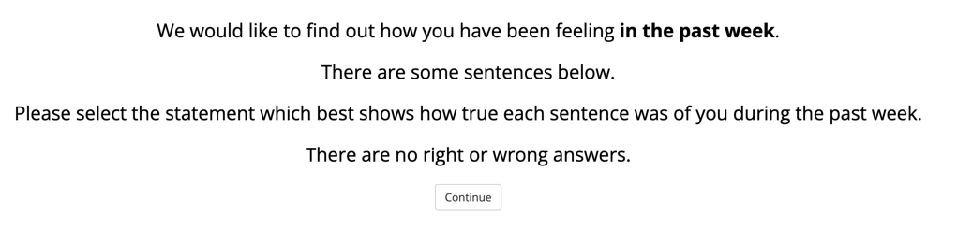

If you would like to modify it to your own, just copy and paste your sentences here:



Text between <b> and </b> is displayed as bold

Adjust font, size, text position, etc.:

Font, size, and text position



Switching to a new line

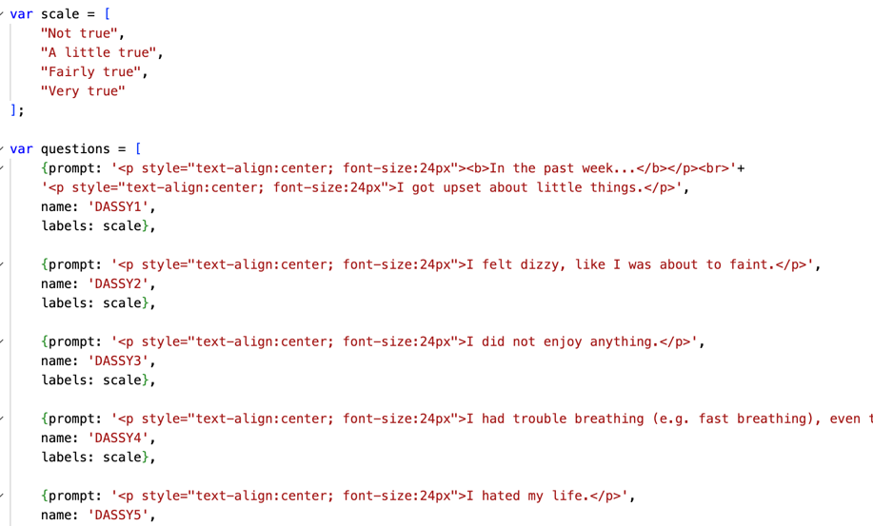

Adding an empty line below this line

Proceed to the next page:

Here we have a button says “continue”



There are many other options for proceeding, e.g.:

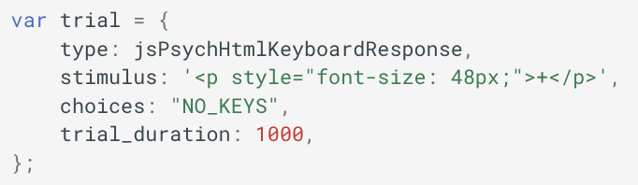

Proceeding to the next page after 1s

Following are the choices and questions:



What’s showing on the web page:

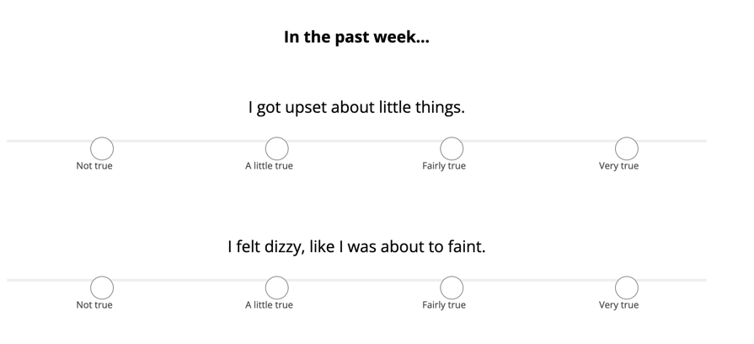

Since we have the same options for all of our questions in this questionnaire, we only need to code that once (the block is called “scale” – you can change the name if you want, but make sure you are using the same name throughout the file) and use them for each individual question:



If the options are different for each of your questions, you can code them separately in the “var questions” block (example: **“16b. SSPDG_likert_block.js”**):

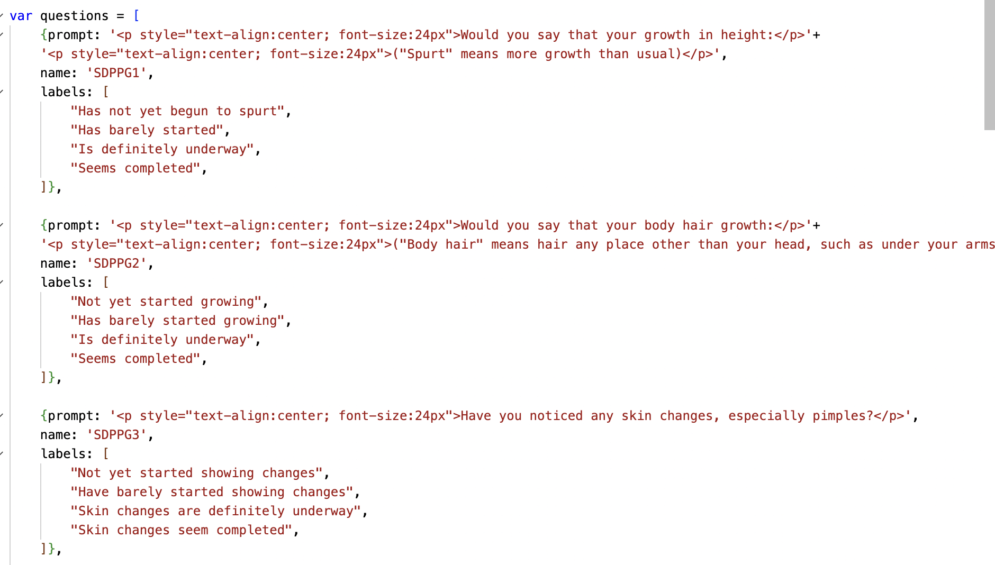

The rest are some settings:

🡨 Force the participants to give an answer to each of the questions

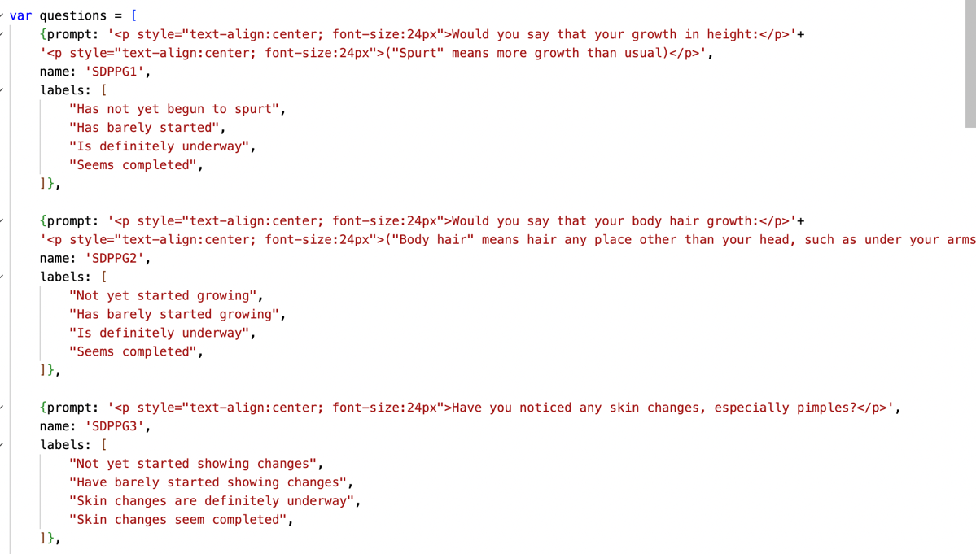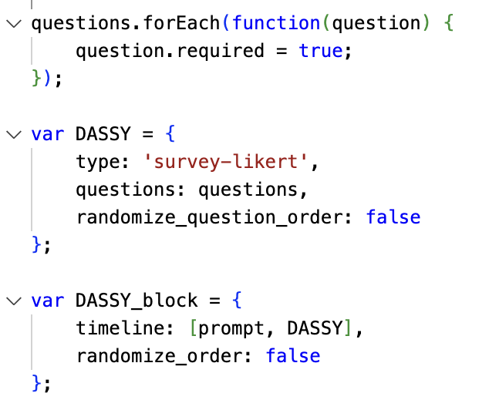

🡨 Deciding the type of the survey (which is Likert Scale here) & bringing in the questions coded above

🡨 The sequence of blocks that you would like to present

Instruction (prompt) 🡪 questions (DASSY)

This is the name that we will be using later in the .html file





## Other Types of Surveys/Functions

JS Psych doesn’t allow you to have different types of functions on the same page (or it’s just me haven’t figure this out☹). So for example, a Likert scale survey and a text response survey have to be coded in separate blocks & presented on different pages.

Here are some examples other than the Likert scale:

1. Surveys with drop-down box (example: “**1. demographics_block.js**”)

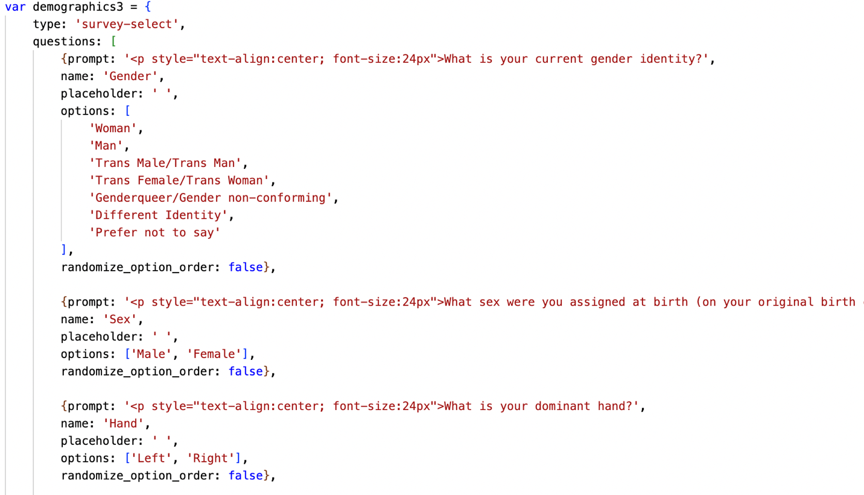

🡨 Other options

🡨 Type of the survey

🡨 Default option

What’s showing on the web page:

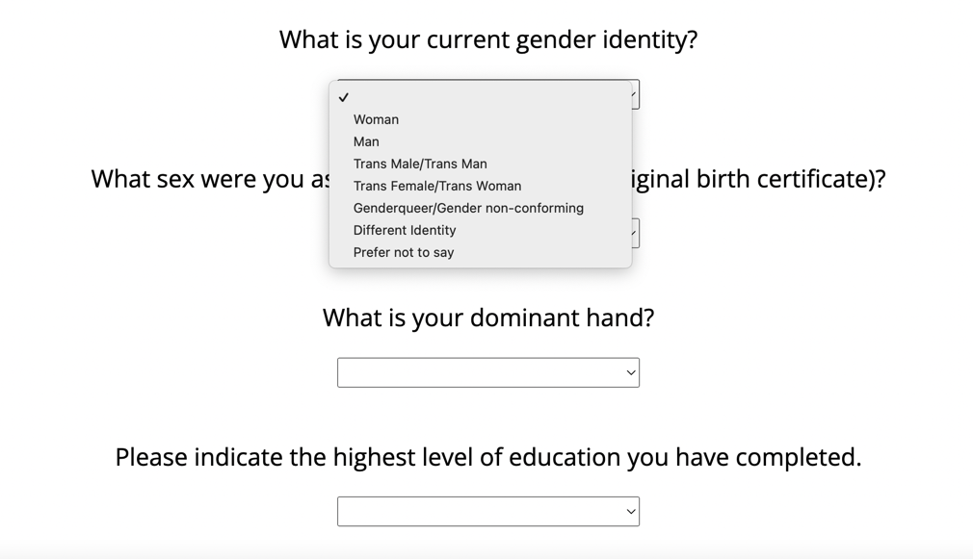

1. Surveys with text response (example: “**1. demographics_block.js**”)

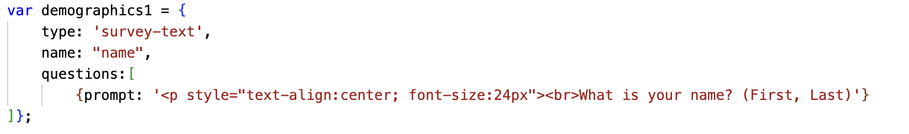

🡨 type of the survey

What’s showing on the web page:

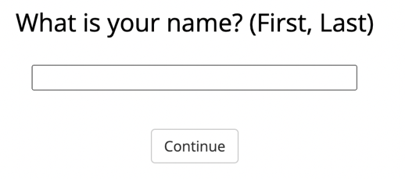

1. Presenting an image (example: “**0. consent_block.js**”)

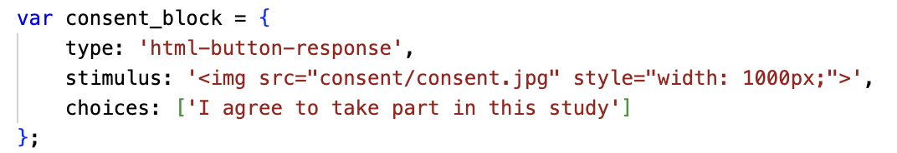

🡨 Inserting the image from the folder

1. Other JS Psych functions include slider, multi-select, or audio/video, see more details on their website: <https://www.jspsych.org/7.3/>

# Combining Individual Files into .html

List all the files you will be using:

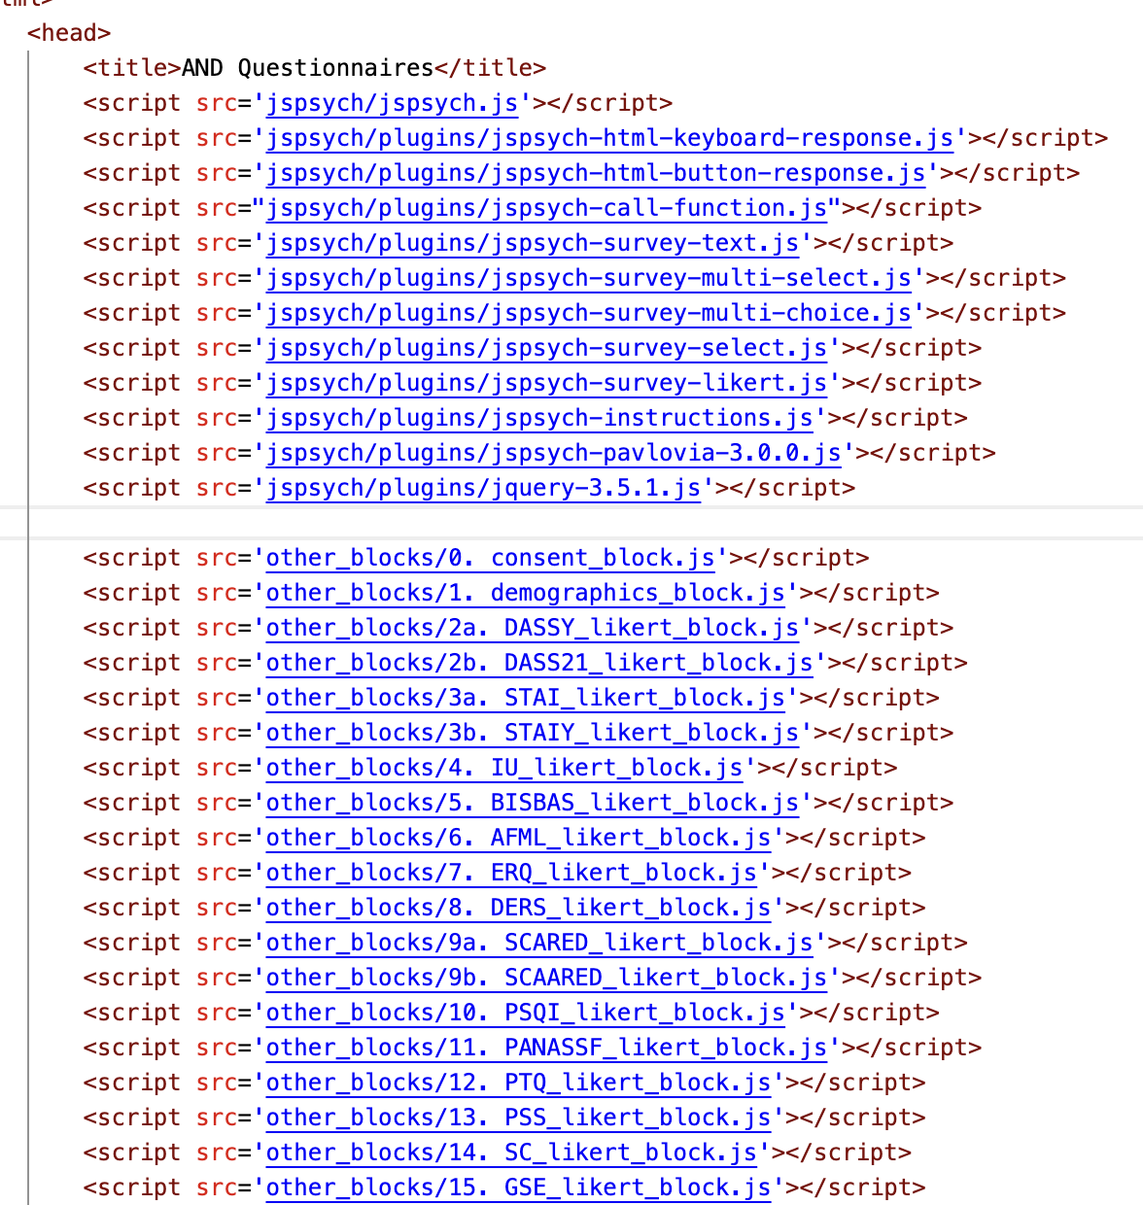

The questionnaire sequence for participants matches the order presented here

If there’s no need to show different participants different things in your study, you can add each individual questionnaire block here (and you are almost done!):

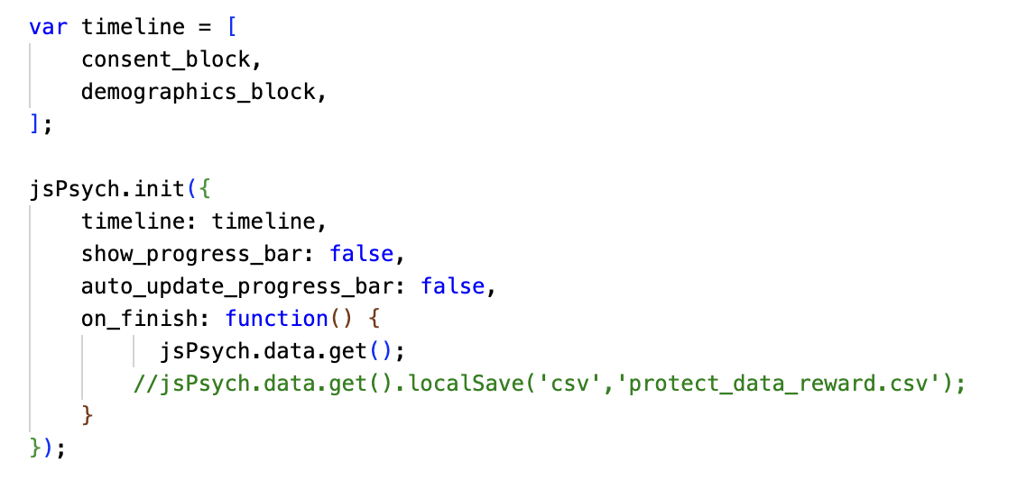

This is the block you have created at the end of each individual files

Saving the data at the end

For our study, we would like to show participants above and under 18 different versions of questionnaires, so it’s a bit more complicated (more in “6. Some Other Things”).

# Uploading for Data Collection

We used a platform called Pavlovia (<https://pavlovia.org/>) for data collection. Just add the following codes before and after your questionnaire blocks:

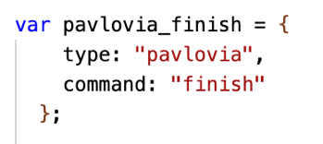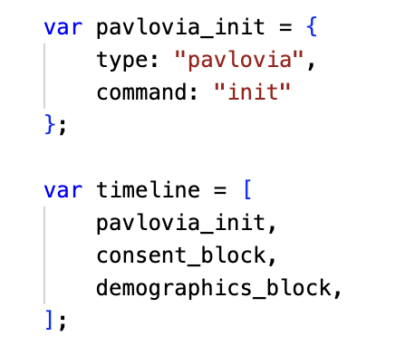

Pavlovia_finish

You can’t open the .html file on your browser anymore after adding these lines, so it’s better to get everything ready before doing so. There is another file (“Instruction_Pavlovia.docx”) on Github that explains how to use the platform.

There are likely to be other platforms or methods for data collection, but we haven’t explored them yet…

# How the Data would Look Like

You will get an excel file for each of your participants:

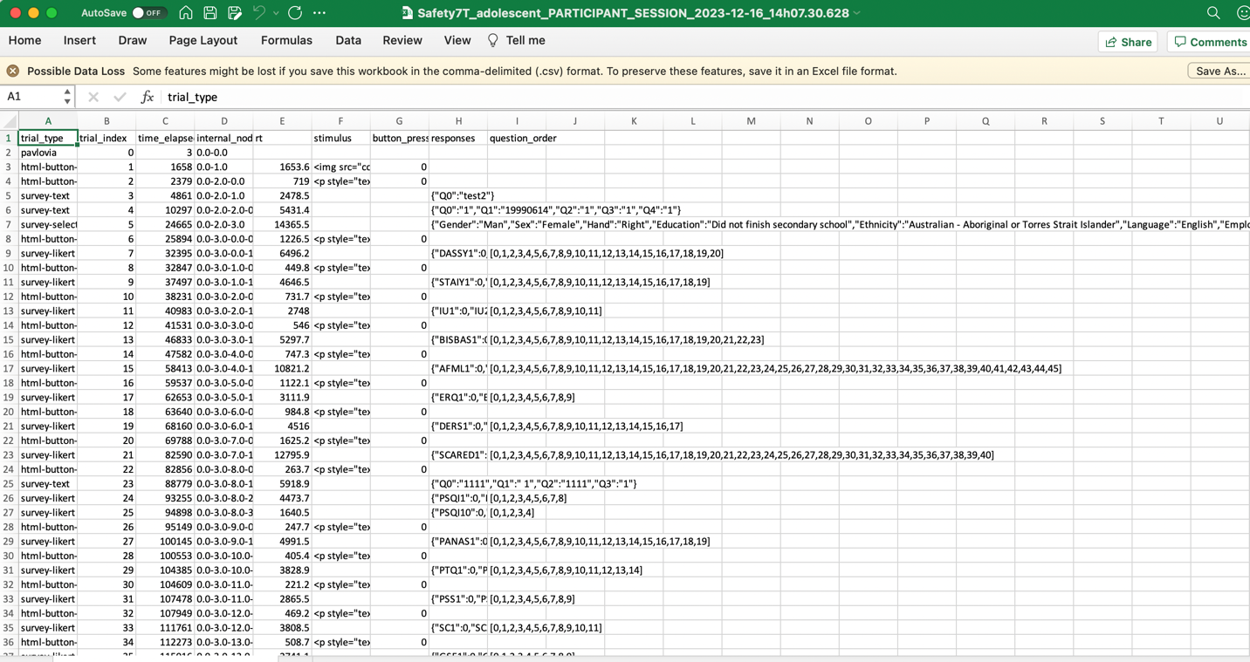

All the answers collected on one web page will be presented in a single cell, so make sure the questions are meaningfully labeled.

A negative example where we forgot to add labels:

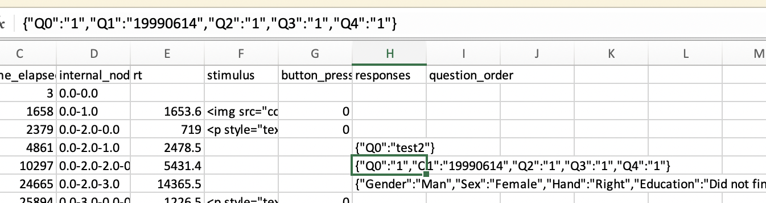

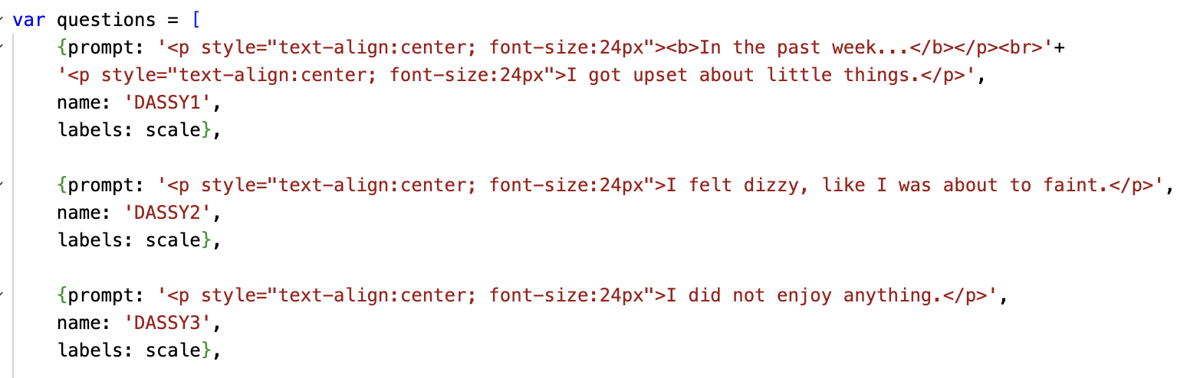

A positive example:

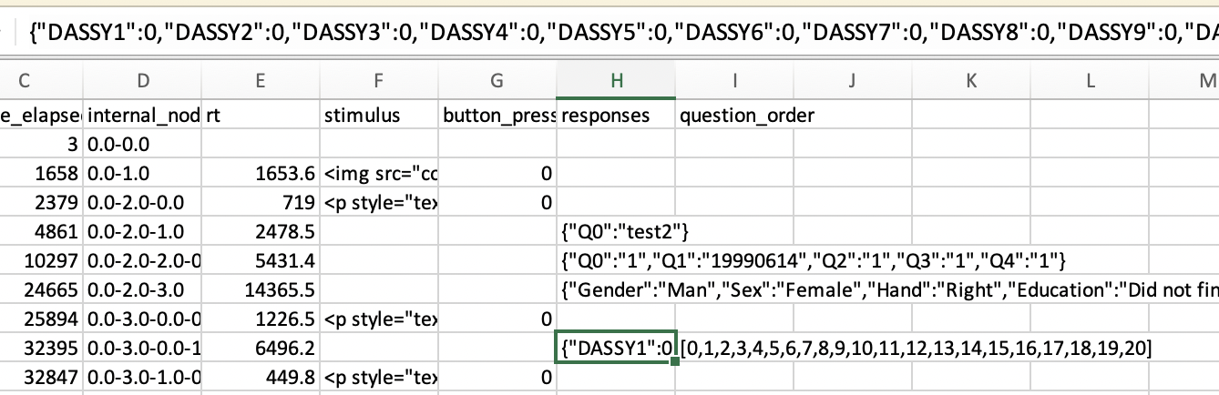

# Some Other Things

## Make Answering Questions Required & in the Right Format

1. For Likert scale and text response surveys, you can add “required: true” directly after the individual question (example: “**1. demographics_block.js**”) 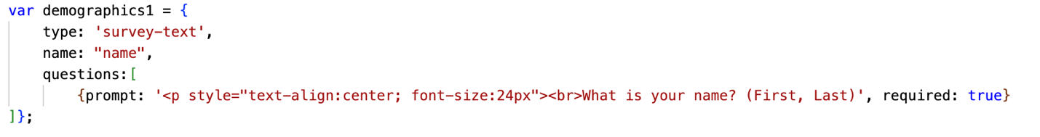

OR you can add the following codes at the end to ensure all the questions within the block are answered (example: “**2a. DASSY_likert_block.js**”):

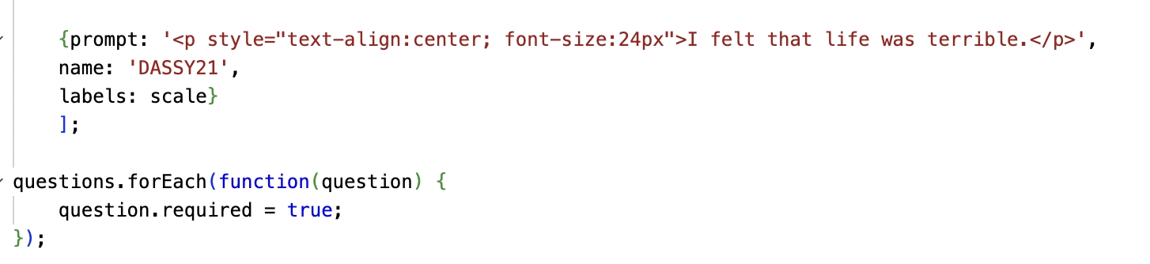

1. For drop-down box, it needs to be modified in the “**jspsych-survey-select.js**” file in “jspsych” 🡪 “plugins”:

🡨 Comment these lines out if you don’t want to force them to answer

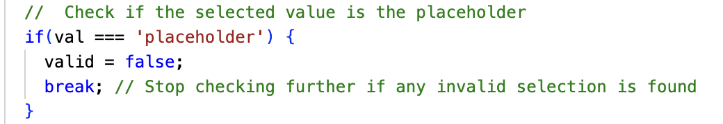

1. You can also ask the participants to fill in digits only (or digits with a certain length) in surveys with text response:

Retrieve all text responses from the question block

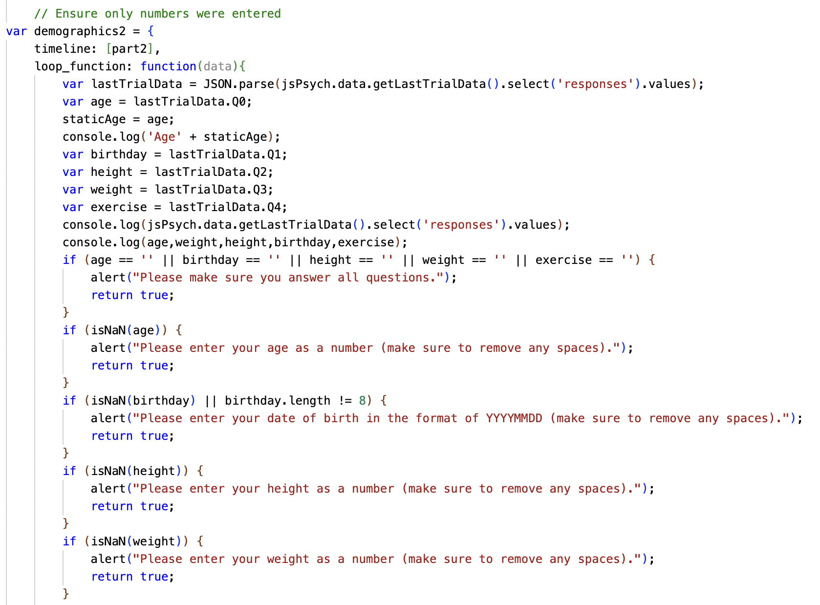

Can only fill in digits

Can only fill in 8 digits

Retrieve the first answer

We didn’t label these questions, and it’s Q0 for the first question by default

🡨 Please ignore these two lines here

## Conditional Questions

Here are the codes if you would like to ask the participants extra questions based on their answers (example: “**16b. SSPDG_likert_block.js**”).

The initial question:

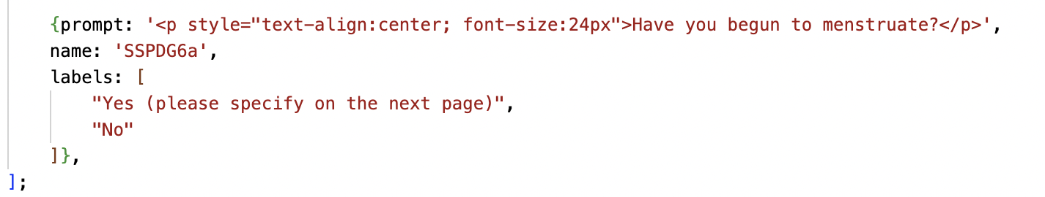

Create a new question block (called “SSPDG6b” here) for the extra questions:

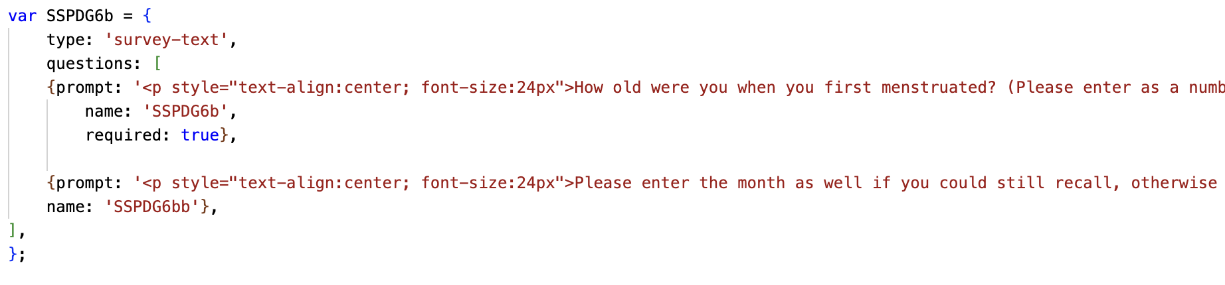

Retrieve all Likert-scale answers from the question block containing the initial question

Retrieve their answers:

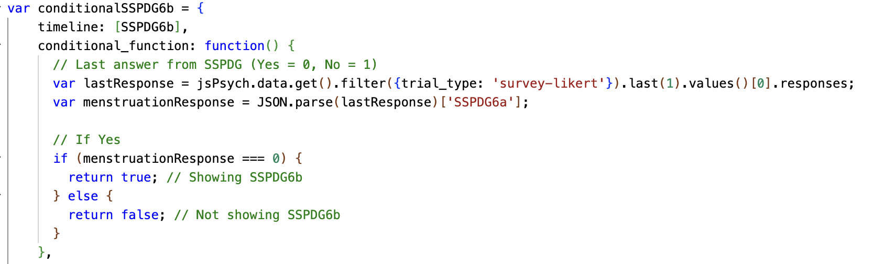

Retrieve the answer for the initial question

🡨 The new question block

Whether to show the extra questions:



In Likert scale surveys, the first option is set to 0 by default

Remember to add it into the timeline at the end:

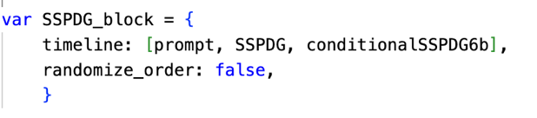

## Showing Different Questionnaires to Different Participants

First you need to decide how you would like to divide your participants into categories. Here we’ve asked for their age and sex (“**1. demographics_block.js**”):

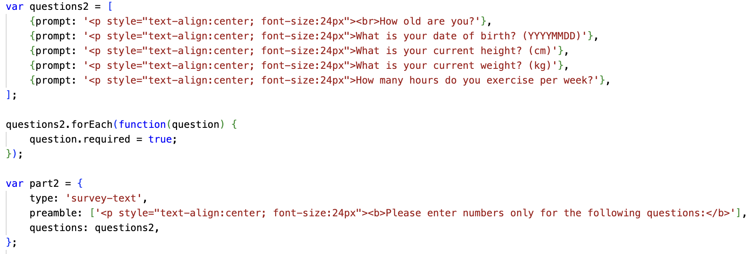

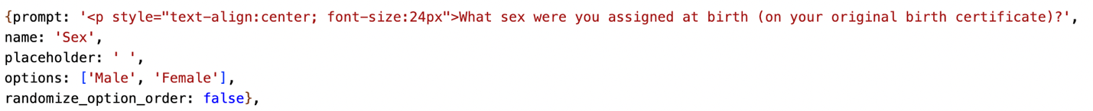

Retrieve their answers:

1. Create global variables

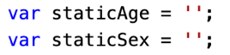

1. Retrieve the answers and save them in the variables

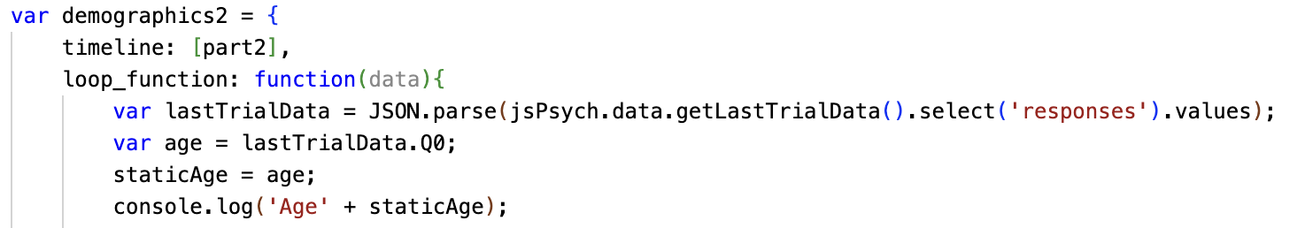

1. A useless step please ignore lol

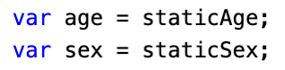

Include different questionnaires for different categories of participants:

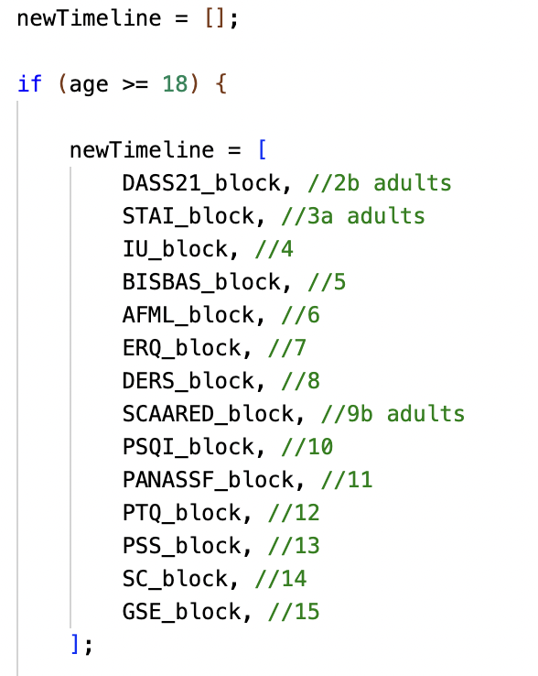

Demographics block

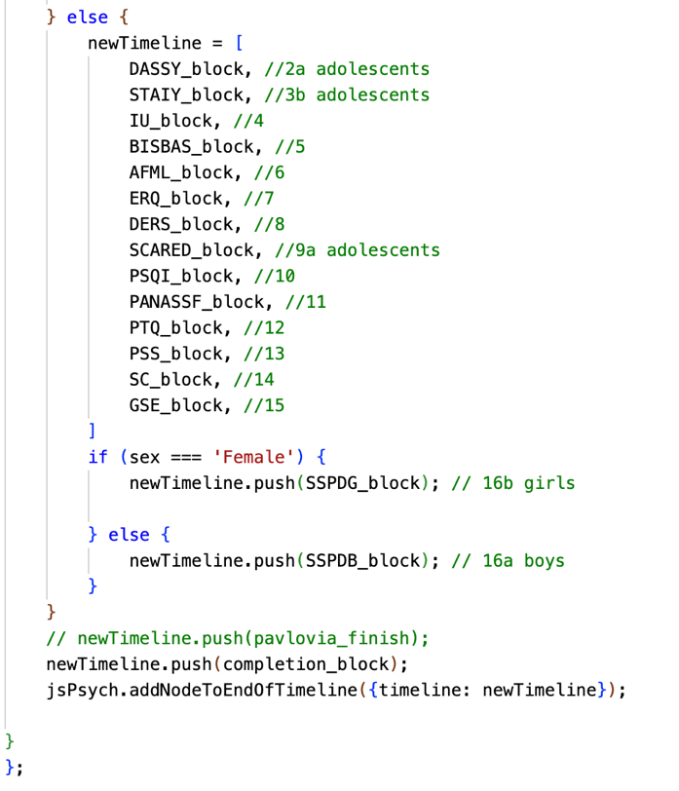

Below 18

Above 18

Male

Female

Completion block

# Trouble shooting

1. If the .html file is blank in your browser, it usually means there is an error in the script. You can right click and choose “Inspect” 🡪 “Console” to check the error.

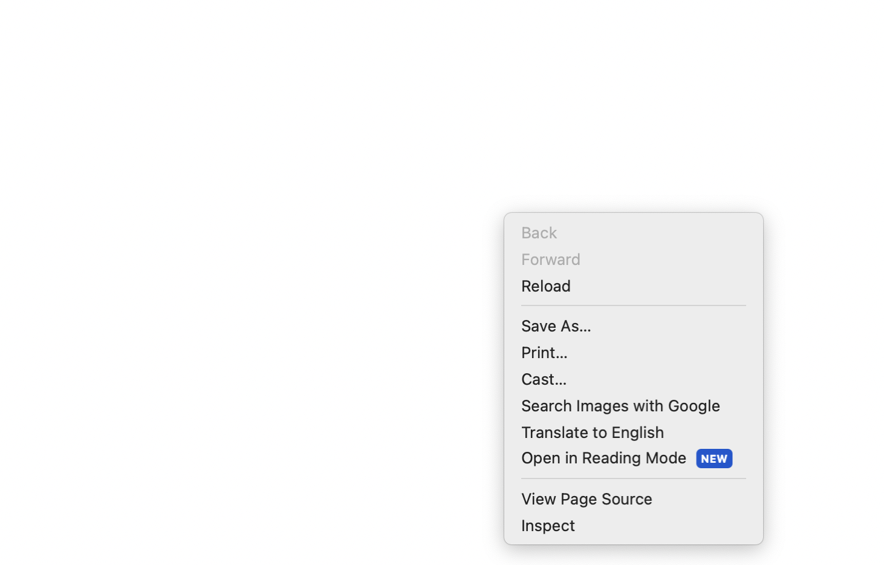

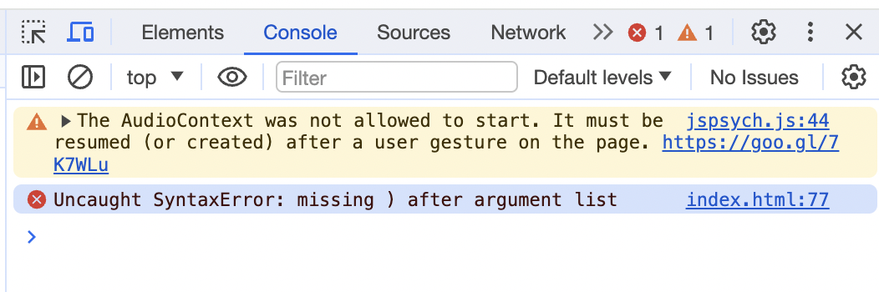

1. If you would like to inspect the outcomes, you can use console.log(THE VARIABLE TO CHECK), and they would appear in your browser (“Inspect” 🡪 “Console”)

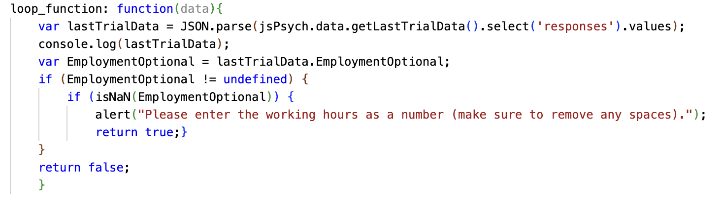

1. If you have any other questions, please contact us at <https://chat.openai.com/>

Just kidding!! Please send an email to Yubing ([yubingz@student.unimelb.edu.au](mailto:yubingz@student.unimelb.edu.au)). I would love to chat about this and anything else!!☺